**TurnQuest General Insurance**

**General Ledger Accounts Mapping Guide**

**By**

**Turnkey Africa Limited**

**Documentation History and Revision**

|  |  |  |  |  |  |
| --- | --- | --- | --- | --- | --- |
| **Document Information and Revision History** | | | | | |
|  | | | | | |
| System | | | TurnQuest General Insurance System | | |
| Title | | | General Ledger Account Mapping Guide | | |
| Author | | | James Kimotho | | |
| Version | | | 5 | | |
| Status | | | Release 1 | | |
| File path | | |  | | |
|  | | | | | |
| HISTORY | | | | | |
| Version | Date | Changes made by: | | Description of Change | Approved By |
| 5 | 16/12/2014 | Victor Mugo | | To incorporate the new way of mapping including RI posting |  |
|  |  |  | |  |  |

Table of Contents

1 Introduction to Account Mapping 4

1.1 Screen 1 4

1.2 Screen 2 5

1.3 Element Types 6

1.4 Element Applicable Levels 7

2 Underwriting (Including Coinsurance & Reinsurance) 8

3 Claims (Including Coinsurance & Reinsurance) 11

4 Accounts Module & Others 14

5 NOTES 16

# Introduction to Account Mapping

General Ledger account mapping functionality is provided in TurnQuest General Insurance to automate the posting of transactions to the correct General Ledger (GL) accounts in the TurnQuest Financial Management System.

Mapping is done on the following screens:

1. Screen 1 *(Setups >> Revenue Items)* – This allows creating new GL mapping elements where not specified and viewing/editing accounts for all sub-classes for a given mapping element.
2. Screen 2 *(Setups >> Classes and Sub Classes)* – This enables attaching of the Account groups to the sub-class so that the sub-class can inherit the account group properties.

## Screen 1

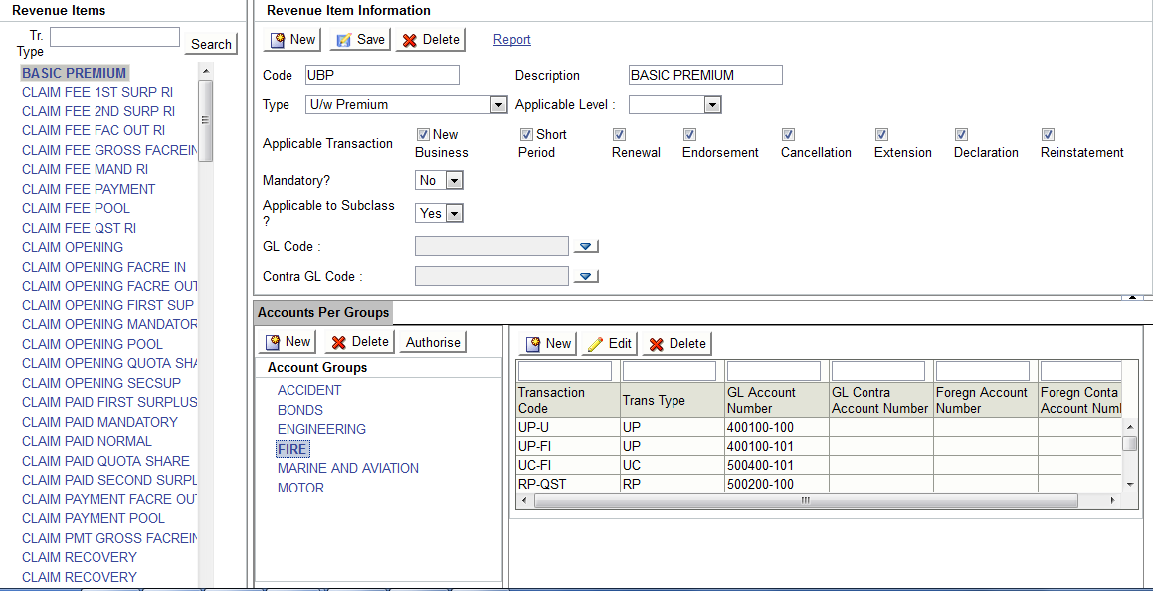

The above screen is used to define any new mapping elements. The following is required to define a new element:

|  |  |
| --- | --- |
| **Label** | **Description** |
| Code | A unique identifier for the mapping element |
| Description | Description of the mapping element |
| Type | These are the various element types that come with the system as further listed in section 2.3 below |
| Applicable Level | These are the various applicable levels in the system as further listed in section 2.4 below |
| Applicable Transaction | Indicates whether the element is applicable for all transaction types. This is only used for taxes and at underwriting |
| Mandatory? | Indicates if the element is mandatory. This is only used for taxes and at underwriting |
| Applicable at Sub Class? | Indicates whether the element is mapped per account group level or not. Where not applicable at Sub class level, the system posts to the indicated GL Account No. Where per sub classes, the user has to map the accounts per account group and the system will use the GL accounts at that level to post into FMS. |
| GL Code | This is the GL accounts where the system posts values for this element. This is only used where Applicable at Sub Class above is set to yes. Else uses the GL Account No. for each account group as specified in sub class accounts |

## Screen 2

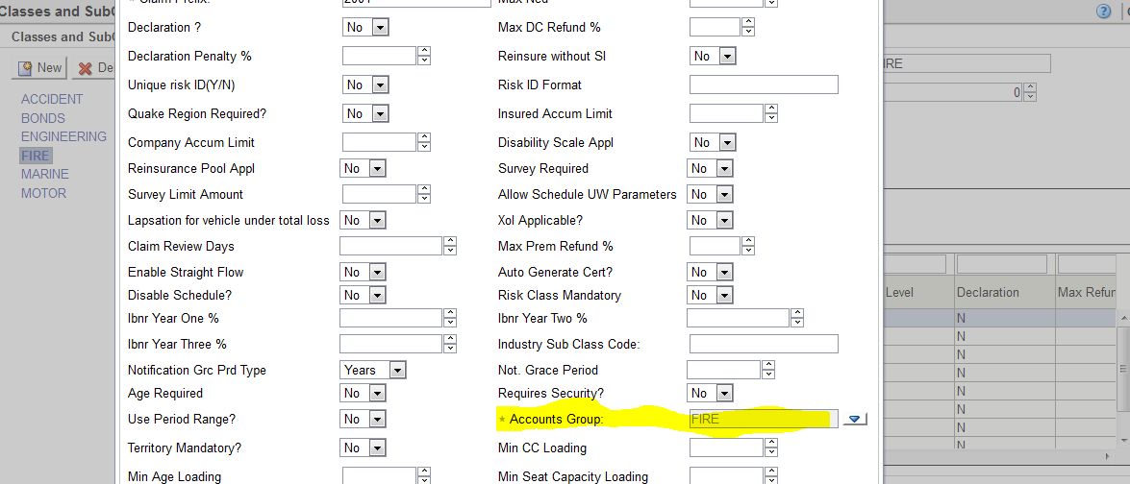

The screen above is used to define “Account group” per sub class. The Account groups “LOV” selects from the pre-defined account groups on screen 1.

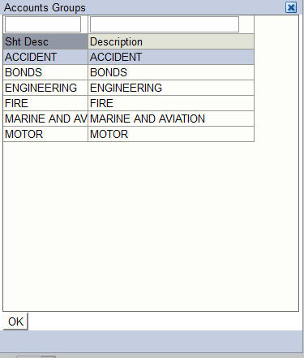

## Element Types

|  |  |
| --- | --- |
| **Module** | **Element Type Label** |
| Underwriting | U/w Premium |
| U/w Tax |
| U/w comm with-holding tax |
| U/w commission |
| U/W Premium Tax |
| U/W Stamp Duty |
| U/W Training Levy |
| Marine Stamp Duty |
| U/W Extras |
| With-Held VAT |
| With-Held Tax Payable |
| Policy Holder Fund |
| Company Policy Holder Fund |
| Reinsurance | R/I Commission |
| RI comm with-holding tax |
| RI int with-holding tax |
| RI premium tax |
| RI Rein premium tax |
| Reinsurance Premium |
| R/I Premium retained |
| R/I Premium released |
| R/I Service fee |
| Pool R/I Premium |
| Pool R/I Commission |
| Pool R/I VAT |
| Claims | Claim Opening |
| Claim Payment |
| Claim Fee Payment |
| Claim Recovery (Excess) |
| Claim Salvage |
| Claim Revision |
| Claim Fee |
| Excess Refund |
| Creditors Follow-up Account |
| Claim Recovery (Third Party) |
| Accounts & Others | IBNR |
| UPR |
| UCR |
| XOL Recovery |
| Write-In Journals |
| Write-Off Journals |
| Marine / Survey Fee |
| Valuation Fee |

## Element Applicable Levels

|  |  |  |
| --- | --- | --- |
| **Label (As shown on screen)** | **Code** | **Description** |
| UW Normal | U | Underwriting Direct business (Agents, Brokers, Direct) |
| Facre In | FI | Underwriting Facultative In |
| Facre Out | FO | Reinsurance Facultative Out |
| Mandatory | MAN | Reinsurance Mandatory Treaty |
| Quota Sh | QST | Reinsurance Quota Share Treaty |
| 1st Surp | FSTSUP | Reinsurance First Surplus Treaty |
| 2nd Surp | SECSUP | Reinsurance Second Surplus Treaty |
| R/I pool | POOL | Reinsurance Pool |
| XOL | XOL | Reinsurance Excess of Loss Treaties |

# Underwriting (Including Coinsurance & Reinsurance)

|  |  |  |  |
| --- | --- | --- | --- |
| **Transaction** | Transaction Component |  | **Comments** |
| **Underwriting Transactions (Direct, Agents, Brokers)**  (Debiting and Crediting shown applies to Underwriting Debit Notes i.e. New Business, Renewal, Extension, Short Period, Additional Premium)  For Underwriting Credit Notes (Refunds) including contras, Cancellations etc, the Debiting/Crediting is reversed. | Premium (Direct, Agents, Brokers) | DR: Source control Account(Asset)  CR: Premium Account.(Income) | * Source Control accounts are setup in FMS System>>External Interfaces. These control accounts depend on the source of business i.e. Agents, Brokers and Direct Accounts. * Premium Account is mapped as GL Code (or GL Account No if at sub class level) |
| Premium (Facultative Inward) | DR: Facre in control account(Asset)  CR: Facre in Premium Account(Income) | * A control account in FMS system from the External interfaces under Facre in account type. * Facre in Premium Account mapped as GL Code (or GL Account No if at sub class level) |
| Policy Holders Fund (Tax. Where applicable) | DR: Source control Account.(Asset)  CR: Policy Holders Account(Liability) | * A Source control account in FMS system from the External interfaces under agents ,broker and direct account types * Policy Holders Account is mapped as GL Code (or GL Account No if at sub class level) |
| Stamp Duty (Tax. Where applicable) | DR: Source control Account.(Asset)  CR: Stamp Duty Account(Liability) | * A control account in FMS system from the External interfaces under agents, broker and direct account types. * Stamp Duty Account is mapped as GL Code (or GL Account No if at sub class level) |
| Training Levy (Tax. Where applicable) | DR: Source control Account.(Asset)  CR: Training Levy Account(Liability) | * A control account in FMS system from the External interfaces under agents, broker and direct account types * Training Levy Account is mapped as GL Code (or GL Account No if at sub class level) |
| Commission (Direct, Agents, Brokers) | DR: Commission Account(Expense)  CR: Source Control Account.(Asset)  {Parameterized:  CR: Commission Payable Accounts(Liability)} | * Commission Account is mapped as GL Code (or GL Account No if at sub class level) * A control account in FMS system from the External interfaces under agents, broker and direct account types * {Commission Payable account is mapped on the contra GL account on the mapping screen in GIS} |
| Commission (Facultative Inward) | DR: Facre in Commission Account(expense)  CR: Facre in Control Account(Asset) | * Commission Accountmapped as GL Code (or GL Account No if at sub class level) * A control account in FMS system from the External interfaces under Facre in account type. |
| Withholding Tax (for intermediaries) | DR: Source Control Account.(Asset)  CR: Withholding Tax Payable(liability) | * A control account in FMS system from the External interfaces under agents, broker and direct account types * Withholding Tax Payable is mapped as GL Code (or GL Account No if at sub class level) |
| **Underwriting Reinsurance**  (Debiting and Crediting shown applies to Underwriting Debit Notes i.e. New Business, Renewal, Extension, Short Period, Additional Premium)  For Underwriting Credit Notes (Refunds) including contras, Cancellations etc, the Debiting/Crediting is reversed. | Treaty Reinsurance Premium | CR: Reinsurance Control Account( Liability)  DR: Treaty Premium Account(Expense ) | * A control account in FMS system from the External interfaces under reinsurance account type. * Treaty Premium Account is mapped as GL Code (or GL Account No if at sub class level) * FSTPREM(First Surplus), SECPREM(Second Surplus), QSTPREM(Quota share), FACPREOU(Facre out) |
| Treaty Reinsurance Commission | DR: Treaty Commission Account(Income)  CR: Reinsurance Control Account(Liability) | * Treaty Commission Account is a mapped as GL Code (or GL Account No if at sub class level) * FSTCOM(First surplus), SECCOM(Second surplus), QSTCOM(Quota share), FACCOMOU(Facre out) * A control account in FMS system from the External interfaces under Reinsurance account type. |
| Facultative Premium | DR: Facre out Premium(Expense)  CR: Facre out Control Account(Liability) | * Facre out Premium **Account** is mapped GL Code (or GL Account No if at sub class level) **FACPREOU** * A control account in FMS system from the External interfaces under Facre out account type. |
| Facultative Commission | DR: Facre out Commission Account(Asset)  CR: Facre out control Account(Liability) | * Facre out Commission Account is mapped as GL Code (or GL Account No if at sub class level) FACCOMOU * A control account in FMS system from the External interfaces under Facre out account type. |
| Pool Premium | DR: Pool Premium(Asset)  CR: Pool Control Account(Liability) | * Pool Premium **Account** is mapped as GL Code (or GL Account No if at sub class level) * A control account in FMS system from the External interfaces under Pool account type. |
| Pool Commission | DR: Pool Commission Account(Income)  CR: Pool control Account (Liability) | * Pool Commission Account is mapped as GL Code (or GL Account No if at sub class level) * A control account in FMS system from the External interfaces under Pool out account type. |
| **Coinsurance**  Where the company only debits/credit for its coinsurance portion of the premium  (Debiting and Crediting shown applies to Underwriting Debit Notes i.e. New Business, Renewal, Extension, Short Period, Additional Premium)  For Underwriting Credit Notes (Refunds) including contras, Cancellations etc, the Debiting/Crediting is reversed. | Premium, Taxes, Commission, Withholding Tax | Same as Underwriting transactions above | Same as Underwriting transactions above |
| Coinsurance Servicing Fee  (ORC) where a leader | DR: Insurance Control (Asset)  CR: Service Fee Account(Income) | * A control account in FMS system from the External interfaces under Insurance account type. * Service fee account is mapped as GL Code (or GL Account No if at sub class level) |
| Coinsurance Servicing Fee  (ORC) where a follower | CR: Insurance Control (Asset)  DR: Service Fee Account (Expense) | * A control account in FMS system from the External interfaces under Insurance account type. * Service fee account is mapped as GL Code (or GL Account No if at sub class level) |
| **Coinsurance Combined**  This is where the company debits/credit for the 100% coinsurance portion of the premium  (Debiting and Crediting shown applies to Underwriting Debit Notes i.e. New Business, Renewal, Extension, Short Period, Additional Premium)  For Underwriting Credit Notes (Refunds) including contras, Cancellations etc, the Debiting/Crediting is reversed. | Own portion of Premium, Taxes, Commission, Withholding Tax | Same as Underwriting transactions above | * Same as Underwriting transactions above |
| Coinsurance Servicing Fee  (ORC) where a leader | DR: Insurance Control (Asset)  CR: Service Fee Account(Income) | * A control account in FMS system from the External interfaces under Insurance account type. * Service fee account is mapped as gl-code |
| Coinsurers Portion Premium (Per coinsurer) | DR: Source Control Account(Asset)  CR: Coinsurer account(Liability) | * A Source control account in FMS system from the External interfaces under agents, broker and direct account types * Coinsurers Accounts is specified in accounts setups in CRM for Insurance companies under the insurance Account type |
| Coinsurers Portion Commission (Per coinsurer) | CR: Source Control Account(Asset)  DR: Coinsurer account(Liability) |
| Coinsurers Portion Withholding Tax (Per coinsurer) | DR: Source Control Account(Asset)  CR: Coinsurer account(Liability) |
| Coinsurers Portion Coinsurance VAT (Per coinsurer) | DR: Source Control Account (Asset)  CR: Coinsurer account(Liability) |
| Coinsurers Portion Training Levy (Per coinsurer) | DR: Source Control Account(Asset)  CR Coinsurer account (Liability) |
| Coinsurers Portion Policy Holders Fund (Per coinsurer) | DR: Source Control Account(Asset)  CR: Coinsurer account(Liability) |
| Coinsurers Portion Extra Charges (Per coinsurer) | DR: Source Control Account(Asset)  CR: Coinsurer account(Liability) |
| **Premium Receipting** |  | CR: Account Type control Account(Asset)  DR: Bank(Asset ) | * A control account in FMS system from the External interfaces under agents, broker, Facultative In and direct account types * Bank account selected at point of receipting |

# Claims (Including Coinsurance & Reinsurance)

|  |  |  |  |
| --- | --- | --- | --- |
| **Transaction** | Transaction Component |  | **Comments** |
| Claim Loss Opening Reserve (LOP) | Gross Reserve (Direct Business) | DR: Claims Incurred A/c (Expense)  CR: Claim outstanding A/c (Liability) | * Incurred claim Account is mapped as gl-code -(**GL Account)** * Outstanding Claim Account is mapped -(**Contra Account**) |
| Gross Reserve (Facultative Inward | DR: Claims Incurred A/c (Expense)  CR: Claim outstanding A/c New(Liability) | * Claim Incurred Account is mapped as gl-code -(**GL Account)** * Outstanding Claim Account is mapped -(**Contra Account**) |
| Treaty Reserve | DR: Claim outstanding Treaty (Liability)  CR: Claim Incurred treaty (Expense) | * **Claim treaty claim** Account is mapped as gl-code * Incurred Claims Treaty Account is mapped as gl-code |
| Facultative Reserve | DR: Claim outstanding Facultative (Liability)  CR: Claim Incurred Facultative (Expense) | * **Claim Facultative** Account is mapped as gl-code (**GL Account**) * Incurred Claims Treaty Account is mapped Contra Account |
| Pool Reserve | DR: Claim outstanding Pool (Liability)  CR: Claim Incurred Facultative New(Expense) | * **Claim Pool** Account is mapped as gl-code (**GL Account**) * Incurred Claims Pool Account is mapped Contra Account |
| Coinsurers Reserve | Not posted to GL | * **Not posted to GL** |
| XOL Opening reserve | DR: Claim outstanding XOL (Liability)  CR: Claim Incurred XOL New(Expense) | * **Claim XOL** Account is mapped as gl-code (**GL Account**) * Incurred Claims XOL Account is mapped Contra Account |
| Claim Loss Reserve Revision (LRV)  (Debiting and Crediting shown applies to Upward revision  For downward revision including contras the Debiting/Crediting is reversed. | Gross Reserve Revision (Direct Business) | DR: : Claims Incurred A/c (Expense)  CR: Claim outstanding A/c New(Liability) | * Incurred claim Loss Account is mapped as gl-code -(**GL Account)** * Outstanding Claim Account is mapped -(**Contra Account**) |
| Gross Reserve Revision (Facultative Inward | DR: Claims Incurred A/c (Expense)  CR: Claim outstanding A/c New(Liability) | * Incurred claim Account is mapped as gl-code -(**GL Account)** * Outstanding Claim Account is mapped -(**Contra Account**) |
| Treaty Reserve Revision | DR: Claim outstanding Treaty (Liability)  CR: Claim Incurred treaty (Expense) | * **Claim treaty** Account is mapped as gl-code Incurred Claims Treaty Account is mapped as gl-code |
| Facultative Reserve Revision | DR: Claim outstanding Facultative (Liability)  CR: Claim Incurred Facultative (Expense) | * **Claim treaty** Account is mapped as gl-code (**GL Account**) * Incurred Claims Treaty Account is mapped Contra Account |
| Pool Reserve Revision | DR: Claim outstanding Pool (Liability)  CR: Claim Incurred Facultative New(Expense) | * **Claim treaty** Account is mapped as gl-code (**GL Account**) * Incurred Claims Treaty Account is mapped Contra Account |
| Coinsurance Reserve Revision | Not Posted to GL | * **Not posted to GL** |
| XOL Reserve Revision | DR: Claim outstanding XOL (Liability)  CR: Claim Incurred XOL New(Expense) | * **Claim XOL** Account is mapped as gl-code (**GL Account**) * Incurred Claims XOL Account is mapped Contra Account |
| Claim Payment (Payments to claimants) | Gross Payment (Direct Business) | DR: Claims Paid Gross (Liability)  CR: Bank (Assets) if Paid by Cash/Cheque  CR: Account Type Control Account where paid by Credit Note. | * Claim Paid Gross Account is mapped as gl-code (GL Account) * Bank account is mapped in FMS system from the External interfaces screen as trans type CLM under the GIS system. * Where the payment is by cheque, the system posts to the bank account specified. Where the payment is by credit note, The amount is posted to the respective control account for the payee's account type. |
| Gross Payment (Facultative Inward | DR: Claims Paid Gross (Liability)  CR: Bank (Assets) if Paid by Cash/Cheque  CR: Account Type Control Account where paid by Credit Note. | * Claim payment Account is mapped as gl-code (GL Account) * Bank account is mapped in FMS system from the External interfaces screen as trans type CLM under the GIS system. |
| Treaty Portion of claim payment | DR: Treaty Control A/C(Liability)  CR: Claim Paid treaty | * Claim Paid treaty (Outstanding Claim Treaty Paid) is mapped as gl-code - (GL Account) * Treaty Control A/C defined in FMS system from the External interfaces under Reinsurance account type. |
| Facultative Portion of claim payment | DR: Facultative Control A/C(Liability)  CR: Claim Paid Facultative | * Claim Paid facultative (Outstanding Claim facultative) Paid is mapped as gl-code (GL Account) * Facultative Control A/C defined in FMS system from the External interfaces under Reinsurance account type |
| Pool Portion of claim payment | DR: Pool Control A/C (Liability)  CR: Claim Paid Pool | * Claim Paid Pool (Outstanding Claim Pool) Paid is mapped as gl-code (GL Account) * Pool Control A/C defined in FMS system from the External interfaces under Reinsurance account type |
| XOL Portion of claim Payment | DR: XOL Control A/C(Liability)  CR: Claim Paid XOL | * Claim Paid XOL (Outstanding Claim XOL) Paid is mapped as gl-code (GL Account) * XOL Control A/C defined in FMS system from the External interfaces under Reinsurance account type |
| Withholding Tax | DR: Withholding Tax Control (Liability)  CR: Withholding Tax Account | * Withholding Tax Controlis mapped as gl-code **WTHTPY** (GL Account) * Withholding Tax Account is mapped as gl-code **WTHTPY** (Contra Account) |
| VAT | DR: VAT Control  CR:VAT Account | * VAT Control is mapped as gl-code WTHVAT (GL Account) * VAT Account is mapped as gl-code WTHVAT|(contra account) |
| Claim Payment - 100% Coinsurance Payment | Payment (Coinsurance 100%) | DR: Claims Paid Gross with own share (Liability)  DR: Coinsurers Control A/C with coinsurers share of payment  CR: Coinsurers Control A/C with coinsurers of VAT and With-holding tax  DR: VAT and With-holding Tax Control A/C with VAT and With-holding tax  CR: Bank (Assets) if Paid by Cash/Cheque  CR: Account Type Control Account where paid by Credit Note. | * Claim Paid Gross Account is mapped as gl-code (GL Account) * Coinsurers A/C defined in FMS system from the External interfaces under Reinsurance account type * Bank account is mapped in FMS system from the External interfaces screen as trans type CLM under the GIS system. * Where the payment is by cheque, the system posts to the bank account specified. Where the payment is by credit note, The amount is posted to the respective control account for the payee's account type. |
| Treaties, Facultative, pool, XOL, own share Withholding Tax and own Share VAT | Same as Non coinsurance payment above | * Same as non coinsurance payment above |
| Claim Salvage | Receipts | CR: Claim Salvage Control A/c  DR: Bank/Cash A/c (Asset) | * A control account in FMS system from the External interfaces under Salvage account type. * Bank account is mapped in FMS system from the External interfaces screen as trans type CLM under the GIS system. |
| Gross Salvage | DR: Claim Salvage Control A/c  CR: Salvage Income A/c(Income) | * OS claim Account is mapped as gl-codeCLMSALVG(GL account) * Salvage Income A/c is mapped as gl-codeCLMSALVG(contra Account) |
| Salvage Treaty Portion | CR: Treaty Control A/C  DR: Claim Salvage treaty | * Claim Salvage treaty (Outstanding Claim Treaty Salvage) is mapped as gl-code - (GL Account) * Treaty Control A/C defined in FMS system from the External interfaces under Reinsurance account type. |
| Salvage Facultative Portion | CR: Facultative Control A/C  DR: Claim Salvage Facultative | * Claim Salvage facultative (Outstanding Claim facultative) Salvage is mapped as gl-code (GL Account) * Facultative Control A/C defined in FMS system from the External interfaces under Reinsurance account type |
| Salvage Pool Portion | CR: Pool Control A/C  DR: Claim Salvage Pool | * Claim Salvage Pool (Outstanding Claim Pool) Paid is mapped as gl-code (GL Account) * Pool Control A/C defined in FMS system from the External interfaces under Reinsurance account type |
| Salvage XOL Portion | DR: XOL Control A/C  CR: Claim Salvage XOL | * Claim Salvage XOL (Outstanding Claim XOL) Salvage is mapped as gl-code (GL Account) * XOL Control A/C defined in FMS system from the External interfaces under Reinsurance account type |
| Salvage Coinsurers Portion | CR: Coinsurers A/C  DR: Salvage Control A/C | * Coinsurance Recovery A/C is mapped as gl-code (GL Account) * Salvage control account defined in FMS system from the External interfaces under Salvage account type. |
| Claim Third Party Recovery | Receipts | CR: Claim Recovery Control A/c  DR: Bank/Cash A/c (Asset) | * A control account in FMS system from the External interfaces under Recovery account type. * Bank account is mapped in FMS system from the External interfaces screen as trans type CLM under the GIS system. |
| Gross Salvage | DR: Claim Recovery Control A/c  CR: Recovery Income A/c (Income) | * OS claim Account is mapped as gl-codeCLMSALVG(GL account) * Salvage Income A/c is mapped as gl-codeCLMSALVG(contra Account) |
| Salvage Treaty Portion | CR: Treaty Control A/C  DR: Claim Recovery treaty | * Claim Recovery treaty (Outstanding Claim Treaty Recovery) is mapped as gl-code - (GL Account) * Treaty Control A/C defined in FMS system from the External interfaces under Reinsurance account type. |
| Salvage Facultative Portion | CR: Facultative Control A/C  DR: Claim Recovery Facultative | * Claim Recovery facultative (Outstanding Claim facultative) Recovery is mapped as gl-code (GL Account) * Facultative Control A/C defined in FMS system from the External interfaces under Reinsurance account type |
| Salvage Pool Portion | CR: Pool Control A/C  DR: Claim Recovery Pool | * Claim Recovery Pool (Outstanding Claim Pool) Paid is mapped as gl-code (GL Account) * Pool Control A/C defined in FMS system from the External interfaces under Reinsurance account type |
| Salvage XOL Portion | DR: XOL Control A/C  CR: Claim Recovery XOL | * Claim Recovery XOL (Outstanding Claim XOL) Recovery is mapped as gl-code (GL Account) * XOL Control A/C defined in FMS system from the External interfaces under Reinsurance account type |
|  | Salvage Coinsurers Portion | CR: Coinsurers A/C  DR: Recovery Control A/C | * Coinsurance Recovery A/C is mapped as gl-code (GL Account) * Salvage control account defined in FMS system from the External interfaces under Recovery account type. |

# Accounts Module & Others

|  |  |  |  |
| --- | --- | --- | --- |
| **Transaction** | Transaction Component |  | **Comments** |
| Premium Receipts (Direct, Agents, Brokers, Facultative In) | Premium receipts | CR: Account Type control Account (Asset)  DR: Bank (Asset) | * A control account in FMS system from the External interfaces under agents, broker, Facultative In and direct account types * Bank account selected at point of receipting |
| Facultative Out Receipts |  | CR: Facultative control Account (Asset)  DR: Bank (Asset) | * A Facultative Control account in FMS system from the External interfaces under Facultative out account type * Bank account selected at point of receipting |
| Facultative Out Payments |  | Reversal of receipt above |  |
| Treaty Receipts |  | CR: Treaty control Account(Expense)DR: Bank (Asset) | * A Treaty Control account in FMS system from the External interfaces under Treaty type * Bank account selected at point of receipting |
| Treaty Payments |  | Reversal of receipt above |  |
| Pool Receipts |  | CR: Pool control Account (Expense DR: Bank (Asset) | * A Pool Control account in FMS system from the External interfaces under Pool type * Bank account selected at point of receipting |
| Pool Payments |  | Reversal of receipt above |  |
| Coinsurance Receipts |  | CR: Coinsurers control Account (Expense  DR: Bank (Asset) | * A Coinsurers Control account in FMS system from the External interfaces under Coinsurers account type * Bank account selected at point of receipting |
| Coinsurance Payments |  | Reversal of receipt above |  |
| Commission Payment |  | DR: Account Type control Account  {Parameterized:  DR: Commission Payable Accounts(Liability)}  CR: Bank | * A control account in FMS system from the External interfaces under agents, broker, Facultative In and direct account types * Bank account selected at point of receipting |
| Write-In |  | DR: Account Type control Account (Asset)  CR: Write-off Accounts in GL (Income) | * A control account in FMS system from the External interfaces under agents, broker, Facultative In and direct account types * Write-off Accounts is specified is mapped as gl-code (GL Account) |
| Write Offs |  | CR: Account Type control Account (Asset)  DR: Write-off Accounts in GL(Expense) | * A control account in FMS system from the External interfaces under agents, broker, Facultative In and direct account types * Write-off Accounts is specified is mapped as gl-code (GL Account) |
| Survey & Valuation Fees |  | CR:Bank  DR: Valuation Expense(Expense) | * Valuation account is mapped as gl-code (GL Account) * Bank account is mapped in FMS system from the External interfaces screen as trans type SUR under the GIS system. |
| Un-Earned Premium Reserves (UPR) | Gross UPR | DR: UPR expense account(Expense)  CR: UPR liability account(Liability) | * UPR expense account is mapped as gl-code * UPR liability account is mapped as a contra account |
| Facultative in UPR | DR:UPR Facre in expense account (Expense)  CR: UPR Facre in liability account(Liability) | * UPR Facre in expense account is mapped as gl-code * UPR Facre in liability account is mapped as a contra account |
| Treaty UPR | DR: UPR treaty liability account (Liability)  CR: UPR treaty expense account(Expense) | * UPR treaty liability account is mapped as a gl account * UPR treaty expense Account is mapped as a contra account |
| Facultative out UPR | DR: UPR Facre out liability (Liability)  CR :UPR Facre out expense account (Expense) | * UPR Facre out liability is mapped as gl code * Facre out expense account is mapped as a contra account |
| Pool UPR | DR:UPR pool liability account (Liability)  CR:UPR Pool expense account (Expense) | * UPR pool liability account is mapped as gl code * UPR Pool expense account is mapped as contra account |
| Un-Earned Commission (UCR) | Gross UCR | DR: UCR liability account(Liability)  CR: UCR expense account(Liability) | * UCR liability account is mapped as gl code * UCR expense account is mapped as the contra account |
|  | Facultative in UCR | DR: UCR Facre in liability account(Liability)  CR: UCR Facre in expense account(Expense) | * UCR Facre in liability account is mapped as gl code * UCR Facre in expense account is mapped as a contra account |
|  | Facre out UCR | DR:UCR Facre out expense account(Expense)  CR:UCR Facre out liability account (Liability) | * UCR Facre in expense account is mapped as gl code * UCR Facre in liability account is mapped as a contra account |
|  | Treaty UCR | DR:UCR treaty expense account(Expense)  CR:UCR treaty liability account(Liability) | * UCR treaty expense account is mapped as gl code * UCR treaty in liability account is mapped as a contra account |
|  | Pool UCR | DR:UCR Pool expense account(expense)  CR:UCR Pool liability account(Liability) | * UCR Pool expense account is mapped as gl code * UCR Pool in liability account is mapped as a contra account |

# NOTES

**NOTE 1**

Where the payment is by cheque, the system posts to the bank account specified. Where the payment is by credit note,

The amount is posted to the respective control account for the payee's account type.

**NOTE 2**

Reinsurance figures are posted to accounts at the participant’s level. Where treaty figures are to be posted into one account, the mapping of the gl-account is done from the revenue items screen per item e.g. first-surplus fire. Else the accounts are setup from the RI treaty screen when attaching the participants.

**NOTE 3**

Facultative figures are posted to individual facultative accounts. These accounts are to be specified in accounts setup section of the TurnQuest CRM System for each Facultative Outward account.